

**Laila**

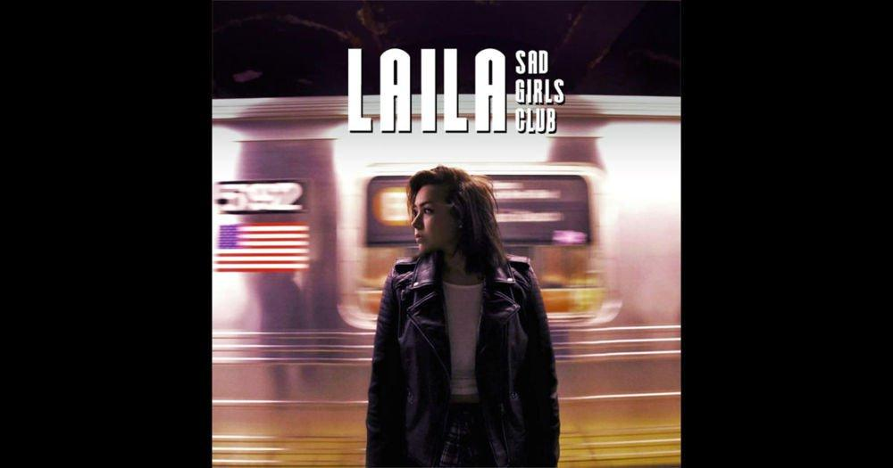

A&R Plan

Artist and Repertoire Music Development

MA Music Business Management

Dominique Di Miceli

Word Count: 1,815

**Table of Contents**

The Artist 3

The Music 3

Why Laila 6

The Aim 8

Short-Term EP Release Timeline 10

Bibliography 11

Appendix 14

*I found Laila through Tumblr a few years ago when she was covering songs by Halsey and 5 Seconds of Summer and through the release of her first original song “90 Proof”. Since then I have been following her on all social media platforms and keeping an on out for when decides to seriously pursue music.*

# The Artist

Laila Fahim, known on social media as Laila Zohra Music, is an American singer-songwriter based in Pittsburgh, Pennsylvania. She began her career in music by posting cover songs to her Tumblr blog and Soundcloud account, covering indie-pop artists with devoted fans such as Halsey, 5 Seconds of Summer and Tove Lo. At this point Laila has released eighteen tracks to her Soundcloud, five songs to Spotify as well as her first EP, *Sad Girls Club*. Laila says Alessia Cara, Halsey and The 1975 influence her, while on Spotify her similar artists are Roy English, Maggie Lindemann, Little Sea, Hayley Kiyoko and Honeywater. Continuing to pursue music seriously, Laila is currently studying for a degree in Entertainment Management at Point Park University in order to gain the skillset needed to succeed as a DIY artist in today’s music industry (Facebook.com). Beginning as a folk-inspired singer, she hopes to explore her sound and break genre barriers into indie-pop with her new electronic tracks like “Maybe, Maybe”.

# The Music

Laila describes her music as “sad songs you can dab to” (Instagram.com). On 24th June 2015 she self-released her first EP *Sad Girls Club* on Spotify, which has had mild success with lead single “Sad Boy” reaching over 450,000 streams.

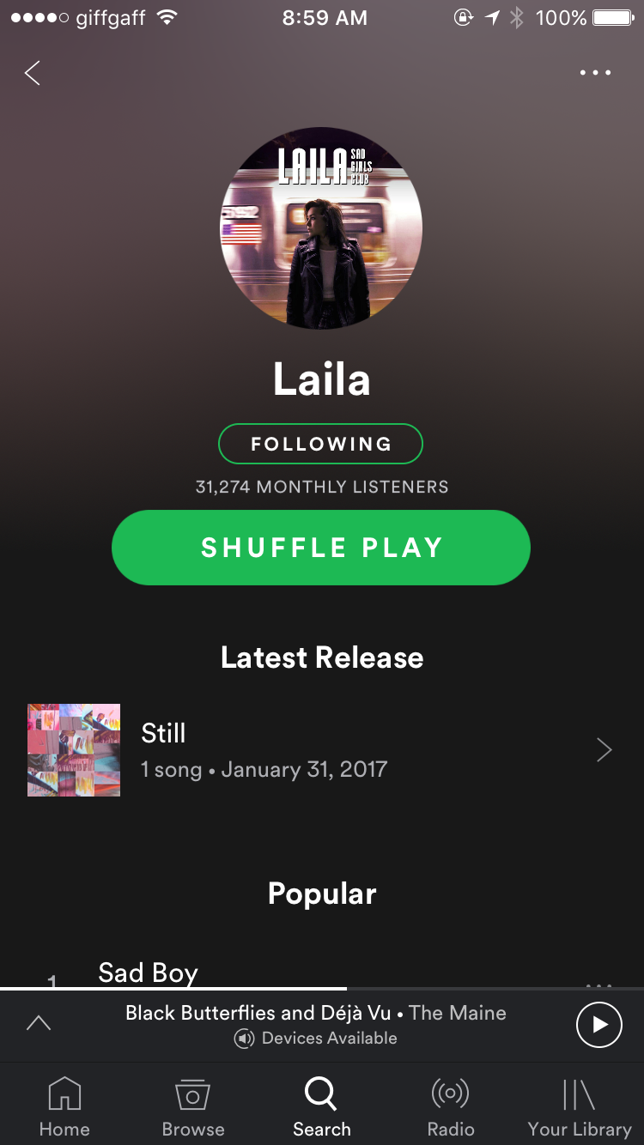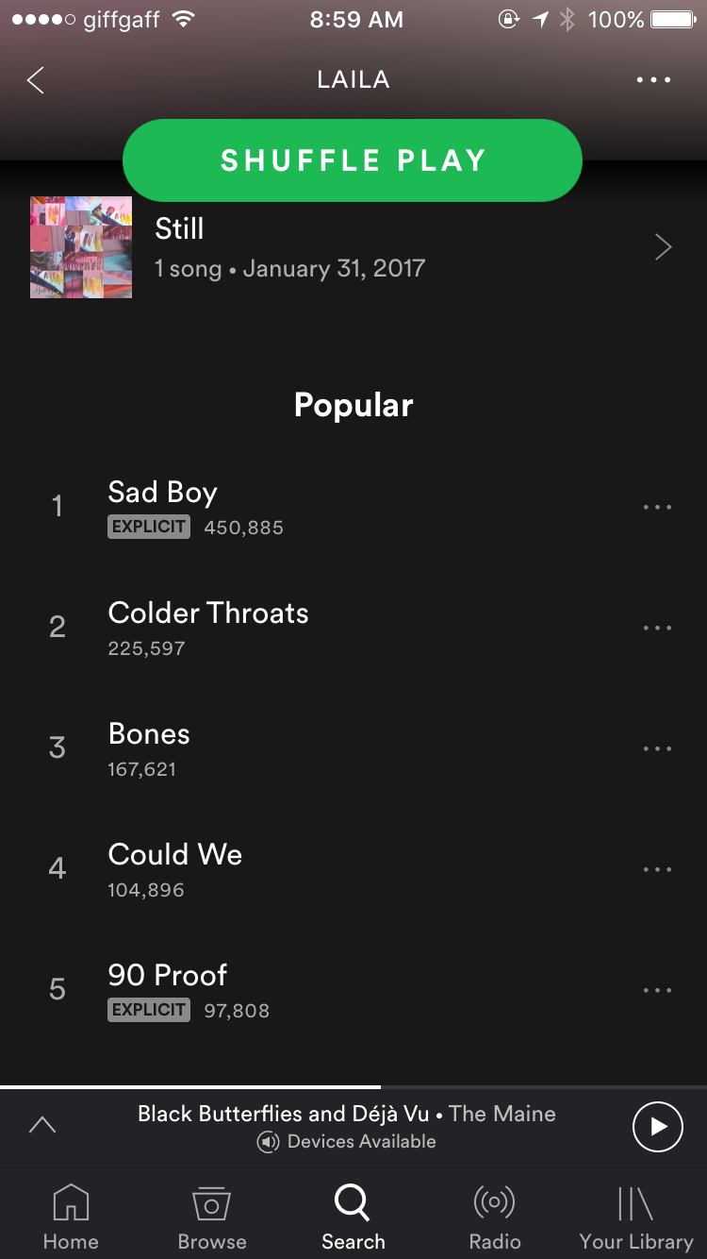

**Figure 1.1** Laila on Spotify

Although her audio posts on Spotify and Soundcloud have had success, she has an inactive YouTube channel with only one video of her singing her song “Colder Throats” as a submission for NPR Music Desk Contest for 2016. Originating as a cover artist covering songs by culturally relevant artists Laila has leveraged their cultural capital (Bourdieu, 1986) in order to draw fans to her music and build her own platform, hence by having a blog on Tumblr enables her to directly reach the devoted fans of the artists. Since pop music and pop culture are embedded into the modern world with a universal appeal to teenagers, Laila needs to increase her music’s online presence to captivate and leverage this audience by way of social contagion and viral culture (Gladwell, 2015). Laila’s power of context (ibid) is that she fits into the current trend of “real” girls (Hamilton, 2017) by representing young people of today dealing with the uncertainty of finding themselves in life and in love. She is a pretty girl who resembles Demi Lovato with a unique aesthetic that is consistent across all platforms.



**Figure 1.2** Laila social media statistics

In order for her to succeed, genre classification needed to identify her sound against others however boundaries are blurred today where an artist has to fit into a genre but “break the rules” in order to create something different and worthy of public interest (Negus, 1992). The pop market needs remixes and high quality productions of songs to classify. Her latest track “Maybe, Maybe” needs extra production to fit genre standards. For example, the introduction is over one-minute long and needs to be shortened to, at most, ten seconds as to not lose the listener. There also needs to be a defined bridge and catchy hook added to fit with traditional structuring. Her lyrics are honest and relatable, stemming from an organic development that is still in process (Negus, 1992), since her early songs were performed and written on guitar with no formal production whereas her current songs have had software editing courtesy of friend producer and DJ Emerson Jay. Although Laila has been working with a producer friend, there is still an issue of quality because although she is writing authentically there is an issue of quality with her tracks questioning the skillset in production of herself and Emerson Jay since in the digital realm anyone can access music software (Perry, 2013; Byrne, 2012). Even without changing to dance tracks, Laila does have potential to be on commercial radio as seen through the success of Ruth B’s piano ballad “Lost Boy”, an abnormal but universally relatable Top 20 hit (Leight, 2016). Some of her lyrics are too raw and controversial for commercial radio play due to adult content. In a wider context, without representation it will be hard for Laila to break into the American market because it is too fickle and saturated anyway (Gross, 2016).

# Why Laila

In attending a liberal arts university, Laila has access to free tools and a wealth of creative student talent who will generally work for free (Ball, 2017). Looking at tour posters for several artists it can be noted that Pittsburgh is a secondary market for music which is helpful to get a start, however to continue it is best for her to spend time in Philadelphia. However, being in Pittsburgh also has its advantages since it is a secondary music market to Philadelphia and has college music fans to play for. Acting as one of Gladwell’s (2015) connectors, I can introduce Laila to Pittsburgh-based photographer Hanna Marie who also attends the same Point Park University. Although four hours away in Philadelphia, Laila can work with my close friends at Darla Hood Productions, a music production company with videography experience from unadvertised colleagues at 7 Axis Studios.

Without a manager or current team helping her, Laila is a true DIY artist self-releasing and self-publishing her music on digital and streaming platforms. The problem with DIY is the paradox of choice, which without any marketing campaigns or playlist features makes it difficult for artists to be discovered by representation and potential fans (McDermott, 2016; Horkheimer et al. 2002). However, the ease of entry and accessibility of the internet enables amateurs to develop an audience through social media but then creates an oversaturation of content that enables the paradox of choice (Wikstrom, 2014). This oversaturation inevitably leads to reproduction and a lack of truly original content (Horkheimer et al, 2002; Perry, 2013), as noted by Laila’s “Colder Throats” being heavily influenced by Daughter’s “Candles”. According to Negus (1992) the biggest help an artist can get is from friends or colleagues who believe in their music or success. The importance of a manager comes from this idea since managers act as a gatekeepers to connections that can help build Laila’s career and an interest in her (Gladwell, 2015). Working with my connections it is highly likely that they will support and promote her on their websites and social profiles to reach a wider audience, also since they are not known content producers if the tracks are a success they will elevate their careers as well.

Laila’s social identity is very simplistic as there are distinct pictures but very little information on her. From a perspective where A&R and marketing overlap, cultivating a brand image is as important as an artist’s musical identity. In order to build her identity, Laila needs a logo and branding practices so that all her social media profiles convey the same message and aesthetic to unify her (Sobh and Elton, 2017). Her Twitter, Instagram and Soundcloud profiles do have a distinct aesthetic that is edgy and nostalgic to compliment her look. Since she is a completely new artist there are no promotions besides promoting herself in audio posts on Tumblr. In order to develop her music career and brand Laila needs to play live shows to prepare herself and practice, playing live will also aid her authenticity merit since it cannot survive on online presence alone (Gladwell, 2015). To develop her social media presence it is necessary to re-launching her YouTube account and the addition of bi-weekly performance videos and additional music videos to hopefully catch the eye of Vevo DSCVR once she builds her brand and public interest. Commercially, the financial value of Laila’s music is limited to the royalties received from Spotify streams (Perry, 2013). By keepings her original songs on Soundcloud and not removing them even though they are on Spotify shows that Laila is more concerned with the distribution of her creativity than of commerce and royalties.

Since A&R is subjective, methods of judging how successful Laila are problematic. According to Greyson Perry (2013) the judgment relies on her music’s her popularity which is measured by her social media followers and plays, and by how her aesthetic identity is received since “aesthetic merits…buying into something” (Perry, 2013), however beauty ideals come from familiarity and reinforcing ideas already in place which works towards her advantage since her looks can be compared to Demi Lovato. Validation is also crucial to artistic success and therefore knowing other artists in the area can help encourage and accept her within the Pennsylvania-area and ultimately help to branch out to other markets. Every day people and media outlets help so validation would need to come from high streaming levels and featuring on Spotify playlists however empirical numbers are because blogs and social media curators give “brownie points” and have more impact in the market than a share from a friend (ibid).

# The Aim

The short-term aim with Laila will be to re-release her *Sad Girls Club* EP with two new songs in order to begin to cultivate a fan base and brand, and use her music to bring attention to complications young adults face. At this stage Laila’s musical works need professional mixing, recording and overall production, which can be a low cost if working with friends and connection. Laila herself needs to be professionally developed as a performer and industry professional, which can be aided by practicing at Open Mic Nites and joining the Philadelphia chapter of The Recording Academy’s Grammy U Program.

In order to rise above the saturation, Laila needs to perfect her online presence through content creation that speaks to her aesthetic (Sobh and Elton, 2017; Gladwell, 2015). Her association to the artists she used to cover is dwindling from when she started since she is inactive on discovery platforms such as YouTube, even though she is developing her own sound there needs to be a reason for listeners to continually click on her music. Noted by Gladwell (2015), Laila must have a “stickiness factor” about her. This factor can be cultivated by building engagement with current listeners, continuing with her signature aesthetic on social media and carrying over to performances, and writing catchy hooks. Laila’s organic development is beginning to take shape with her self-written songs, unique singing style and ability to self-release and self-publish.

# Short-Term EP Release Timeline



# Bibliography

Ball, G. (2017) *Integrated Marketing.*

bandcamp.com. (n.d.). *laila*. [online] Available at: https://laila.bandcamp.com/ [Accessed 31 Mar. 2017].

Byrne, D., 2012. How Music Works. Canongate Books.

Darla Hood Productions. (n.d.). [online] Available at: http://www.darlahoodproductions.com/ [Accessed 31 Mar. 2017].

Facebook.com. (n.d.). *Laila Fahim*. [online] Available at: https://www.facebook.com/lzfahim [Accessed 31 Mar. 2017].

Fahim, L. (2016). *Colder Throats - Laila (NPR Music Desk Contest 2016)*. [video] Available at: https://www.youtube.com/watch?v=8qojwGUpQOs [Accessed 31 Mar. 2017].

Fahim, L. (n.d.). *tales of a sad mixed girl*. [blog] Satinblues.tumblr.com. Available at: http://satinblues.tumblr.com [Accessed 3 Apr. 2017].

Gladwell, M. (2015). *The Tipping Point.* London: Abacus.

Gross, S. (2017). *Ethical Living.*

Hamilton, J. (2017). *Finding the Voice*.

Horkheimer, M., Adorno, T.W. and Noeri, G. (2002). Dialectic of Enlightenment. Stanford University Press.

Instagram.com. (n.d.). *laifam (@lailazohramusic)*. [online] Available at: https://www.instagram.com/lailazohramusic/ [Accessed 31 Mar. 2017].

Leight, E. (2016). *Ruth B's 'Lost Boy' And The Story Behind The Year's Strangest Hot 100 Hit*. [online] Billboard. Available at: http://www.billboard.com/articles/columns/pop/7334174/ruth-b-lost-boy-hot-100-hit-finding-neverland [Accessed 3 Apr. 2017].

McDermott, J. (2016). *How Spotify Solved for the ‘Paradox of Choice’*. [online] MEL Magazine. Available at: https://melmagazine.com/how-spotify-solved-for-the-paradox-of-choice-28c4a2f0d09f [Accessed 3 Apr. 2017].

Negus, K. (1992). Producing Pop: Culture and Conflict in the Popular Music Industry. E. Arnold.

Perry, G. (2013). *Playing to the Gallery – Democracy Has Bad Taste*.

Sobh, S. and Elton, R. (2017). *Digital Marketing*.

Songkick. (n.d.). *Halsey*. [online] Available at: http://www.songkick.com/artists/8067338-halsey [Accessed 3 Apr. 2017].

Songkick. (n.d.). *Ruth B*. [online] Available at: http://www.songkick.com/artists/8675084-ruth-b [Accessed 3 Apr. 2017].

Songkick.com. (n.d.). *Alessia Cara Gigography, Tour History & Past Concerts – Songkick*. [online] Available at: http://www.songkick.com/artists/8568579-alessia-cara/gigography?page=3 [Accessed 3 Apr. 2017].

Songkick.com. (n.d.). *Hayley Kiyoko Gigography, Tour History & Past Concerts – Songkick*. [online] Available at: http://www.songkick.com/artists/5977939-hayley-kiyoko/gigography [Accessed 3 Apr. 2017].

Songkick.com. (n.d.). *Melanie Martinez Gigography, Tour History & Past Concerts – Songkick*. [online] Available at: http://www.songkick.com/artists/6647159-melanie-martinez/gigography?page=1 [Accessed 3 Apr. 2017].

Songkick.com. (n.d.). *The Maine Gigography, Tour History & Past Concerts – Songkick*. [online] Available at: http://www.songkick.com/artists/59712-maine/gigography?page=17 [Accessed 3 Apr. 2017].

SoundCloud. (n.d.). *laila*. [online] Available at: https://soundcloud.com/lailazohramusic/tracks [Accessed 31 Mar. 2017].

Twitter.com. (2013). *laifam (@lailazohramusic)*. [online] Available at: https://twitter.com/lailazohramusic [Accessed 31 Mar. 2017].

Wikström, P. (2014). *The Music Industry: Music in the Cloud*. 1st ed. Cambridge: Polity Press.

## Appendix

**Appendix 1** Laila Soundcloud

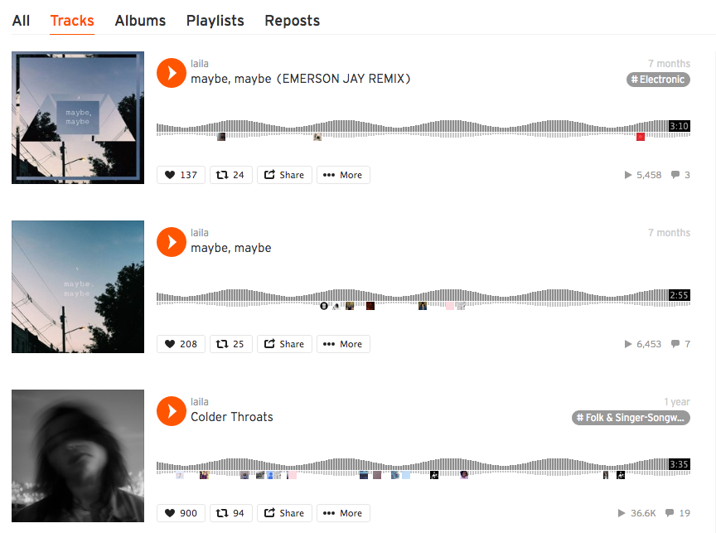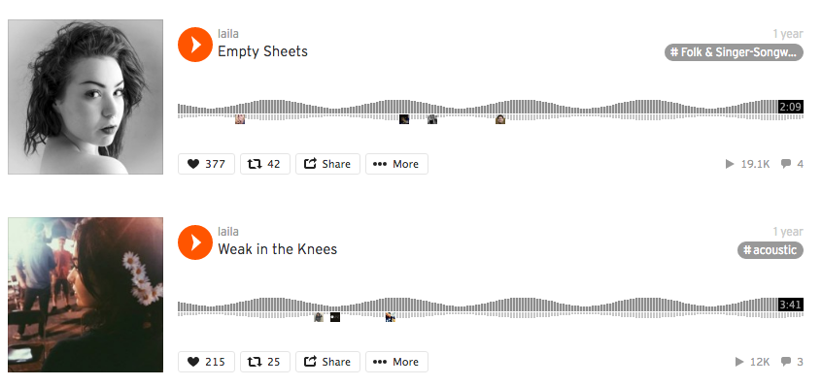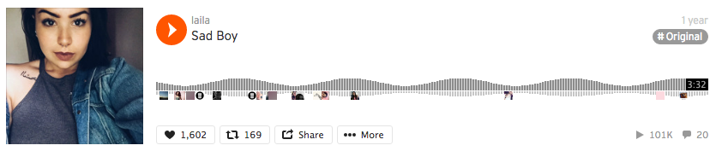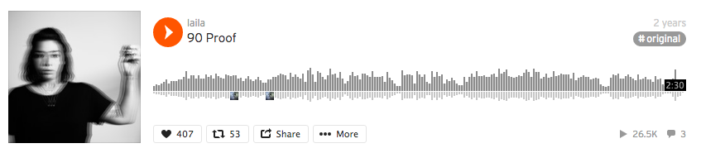

**Appendix 2** Laila EP on Soundcloud 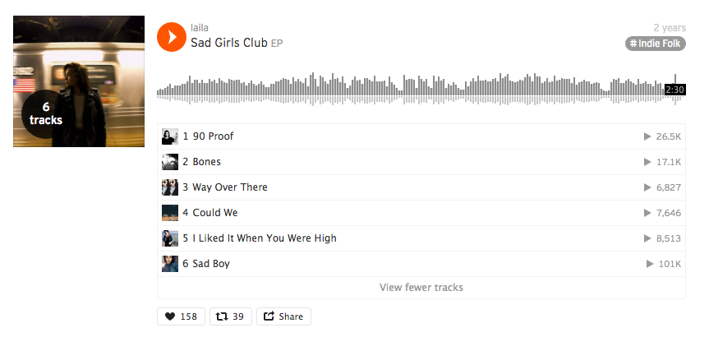

**Appendix 3** Laila Instagram